NATIONAL UNIVERSITY OF MODERN LANGUAGE ISLAMABAD
Lab 06


Submitted to:
Ms. Saadia Shabbir
Submitted by:
Zulqarnain Hassan
Roll No: …………………… SP21379
Subject: …………………… Web engineering
Department: ……………… BSSE-5-Afternoon
Date: ……………………… 18-11-2024

Q1 Perform the exercises on the following CSS topics and create two web pages using following
• Font properties (e.g Web Fonts) and Text properties (e.g Text Effects, Shadows)
• Links in CSS
• Backgrounds properties (e.g Background size, Background Attachment Property etc )
• CSS border properties (e.g border block property, Border bottom ,border images etc)
• Gradients
• Colors(RGB RGBA HSL HSLA)
• 2D Transformation
• 3D transformation
• Transitions
• Animation

Page1

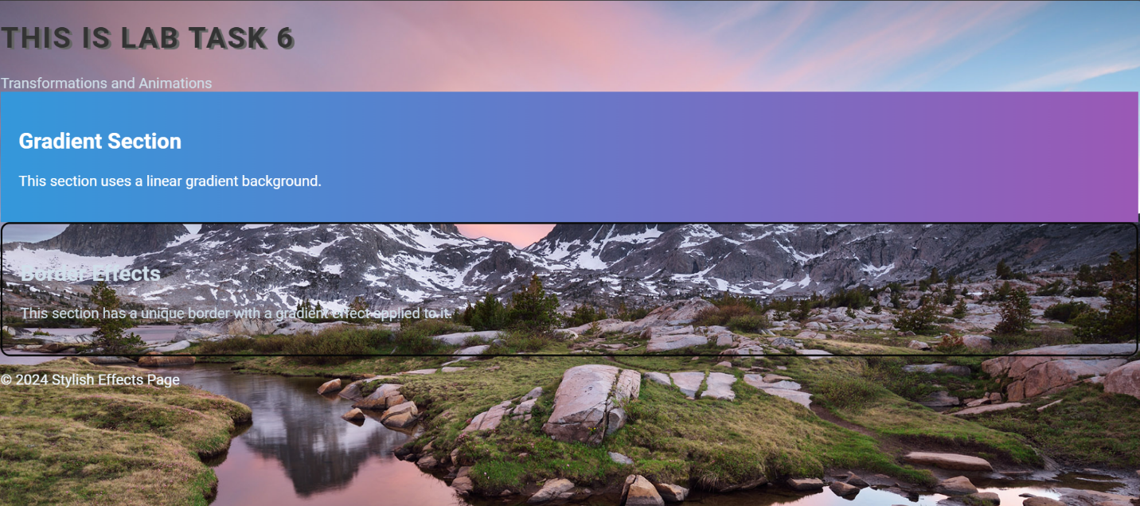

Page2

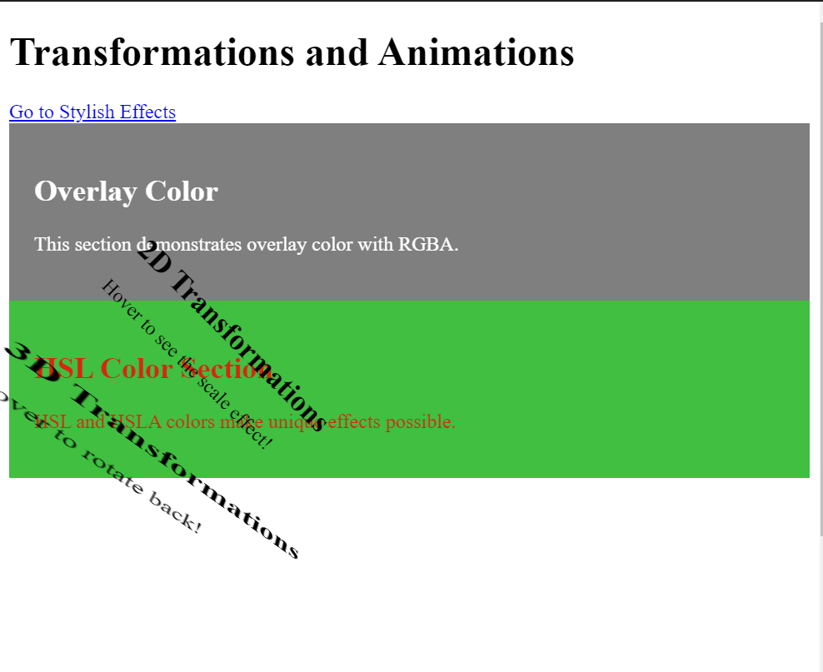

Task 2
